**7 Windows features I enabled that weren't turned on by default**

Story by João Carrasqueira

[Windows 11](https://www.xda-developers.com/windows-11/?utm_source=syndication&pubDate=20250721) is a big and fully-featured operating system that can do a lot out of the box. You may know that much, but even with everything it already enables when you first set it up (for better or worse), there's a lot more it can do by just browsing the Settings app and enabling additional features.

In fact, some of the best and most important features in Windows 11 are not enabled by default, and it's up to you to hunt them down and turn them on. Here are a few that I always recommend checking out if you want your PC experience to be the best it can be.

**Nearby sharing**

**It's all in the name**

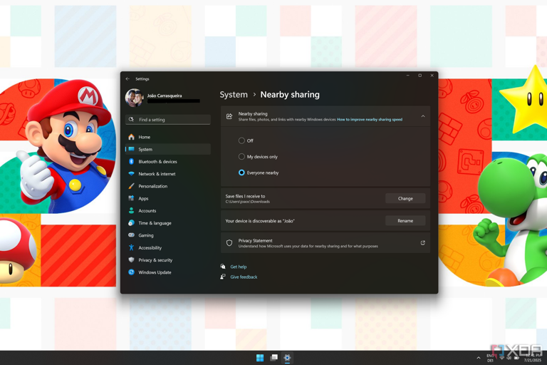

Screenshot of Windows 11 Settings app showing nearby sharing enabled

Nearby sharing is a feature in Windows 11 that allows you to easily share files with PCs near yours. It can detect nearby computers using Bluetooth and send files using a local wireless connection, and it can also detect computers connected to the same network as you, making it easier to send files to other devices without having to send them through a server on the internet.

Nearby sharing is, however, not enabled by default, so you'll have to go into the Settings app to get it working. You can find this option in the **System** section, and the page itself is just called **Nearby sharing**. You can make it so that your PC can detect any other PCs in the vicinity, or limit it to PCs that are signed in using the same Microsoft account so you can have a bit more control over the experience.

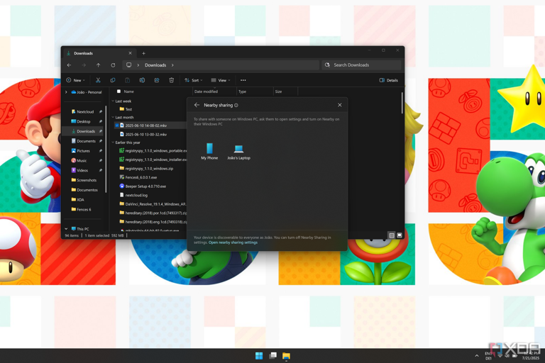

Screenshot of File Explorer on Windows 11 with the share menu showing nearby sharing options

Unfortunately, nearby sharing only works with Windows devices, so it falls behind options like Google's Quick Share, but for having it built-in, this is still a great addition.

**Storage Sense**

**Keep your PC clean**

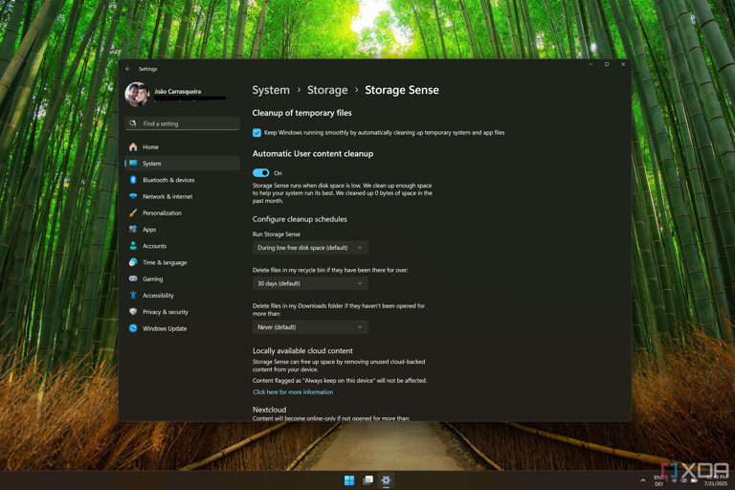

Screenshot of the Storage sense page in Windows 11 Settings

Windows has long offered tools to help you remove unnecessary files to free up space, specifically with Disk Cleanup, which can be found in the Settings app these days (or a version of it, anyway). But if you don't want to do this work manually, there's a feature called Storage Sense that can help clean up after you without requiring you to constantly keep an eye on your storage usage.

In recent versions of Windows 11, Storage Sense is enabled by default, but it will only run when storage space is low, so you might not notice it doing much of anything until your disk space is already worryingly low. Thankfully, if you go into the Settings app, under **System > Storage > Storage Sense**, you can set the cleanup process to run on a monthly, weekly, or daily basis. You can also set up options for specific kinds of cleanup, such as deleting files in your Downloads folder if you haven't touched them for a certain length of time, or deleting local copies of files in your cloud services.

**Automatic time zone switching**

**For when you have to travel**

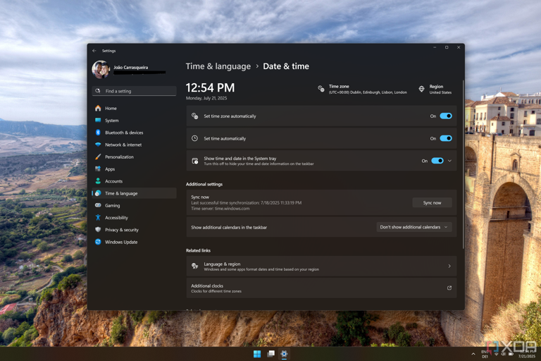

Scxreenshot of date and time settings in Windows 11 with the option to set the tmie zone automatically enabled

Out of the box, Windows automatically updates its clock through the official Windows time server, but it only changes it to whatever time it is in the time zone you chose initially. If you're travelling to a different time zone, however, Windows won't automatically update its clock to match that, which can feel a bit odd since devices like your phone usually do.

Oddly enough, though, Windows *can* do this, it's just that the option is turned off by default. To turn it on, you'll need to go into the Settings app and visit the **Time & language** section, then choose **Date & time**. The option to **Set time zone automatically** is right near the top, but to turn it on, you'll also need to enable location services on your PC if you haven't already. That may be a trade-off not everyone wants, but it does make things a lot easier.

**Wireless display**

**Use your laptop as a second screen**

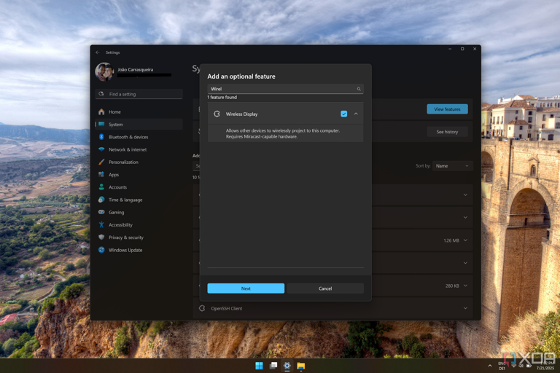

Screenshot of the optional features page in Windows 11 Settings showing WIreless display as a feature to be isntalled

Did you know that the majority of modern laptops can serve as a second display for another computer? Thanks to Miracast technology, most modern computers can be used as wireless displays, and you can even use your mouse and keyboard to control the remote device. However, Microsoft doesn't enable this feature by default, nor does the company make it very apparent that such a feature even exists.

However, if you open the Settings app and go to **System > Optional features**, you can install the Wireless Display feature, which will make it possible to project content to your PC wirelessly using Miracast. You can then set this up in **System > Projecting to this PC**, where you can open it up to any nearby device that supports Miracast, or make it so that only PCs with the same Microsoft account can project to your PC.

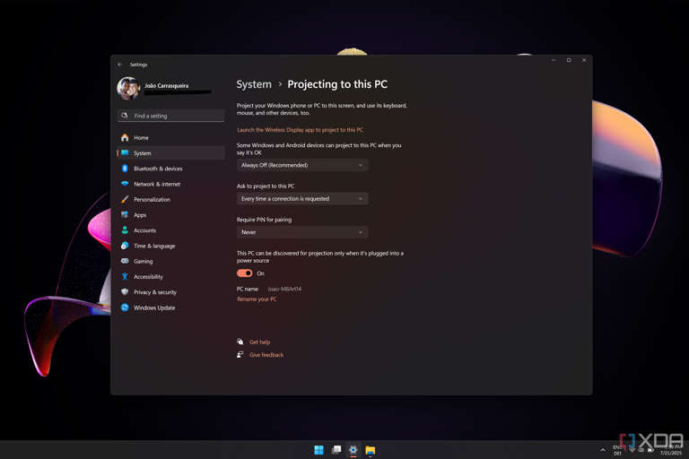

Screenshot of the Windows 11 Settings app showing options for projecting to the PC

If you're concerned about letting people cast to your PC, don't worry — you'll always need to approve the connection first, so it's not like someone can just take over your screen unprompted.

**HDR**

**Make movies and games more lively than ever**

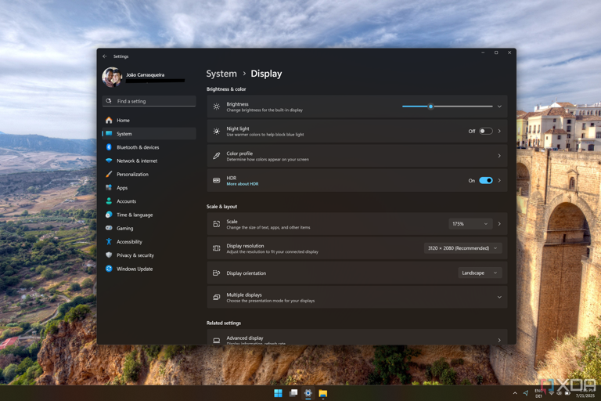

Screenshot of WIndows 11 display settings showing HDR is turned on

With how popular HDR tends to be as a feature, you might think it would be something Windows has enabled out of the box to provide the best experience possible. However, HDR is still off by default when you install Wiondows from scratch, so you'll need to turn it on if you want the best dynamic range for your movies and games. HDR makes it so that brighter and darker areas of the image can be displayed at the same time the way they were designed, without losing detail in either the highlights or the shadows.

To enable it, you'll need to open the Settings app and go to **System > Display**, then turn the HDR setting on. You can also configure various aspects of the HDR experience, such as whether it should be used on battery power (though it will consume a lot more battery this way), and calibrate it so it offers the best possible experience on your specific display.

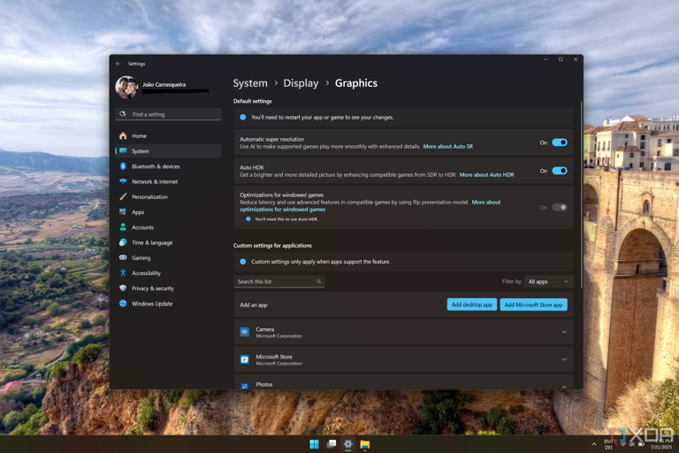

Screenshot of Windows 11 graphics settings showing Auto HDR is on

If you do enable HDR in general, you may also want to go into the **Settings > Display > Graphics** and enable **Auto HDR**. This is a feature that, for suported games, enables automatic tone mapping to add HDR support to games that don't support it out of the box.

**Night light**

**Save your eyes**

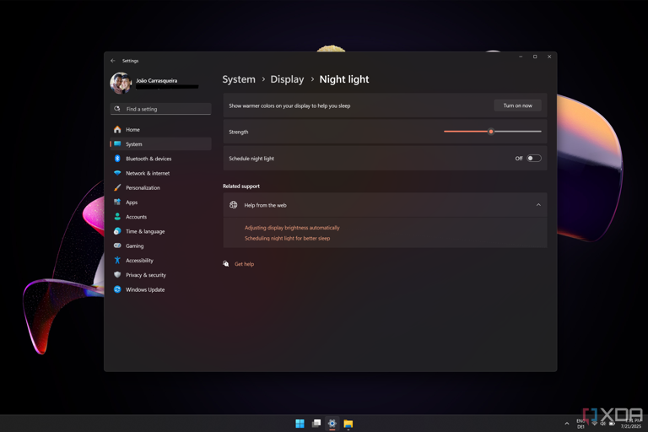

Screenshot of night light settings on Windows 11

If you spend all day in front of a computer like I do, chances are your eyes are going to get very tired after a while, and it's all the worse if you work late into the night. Blue light emissions from your screen can hurt your eyes and (according to some studies) affect your sleep schedule, so Windows has a feature called Night Light, which reduces the intensity of the blue light emitted by your screen to try and improve your eye health.

Night light has been in Windows for years, but you still have to set it up manually. You can enable it in the Settings app, under **System > Display**, and you have some additional configuration options so that night light follows the sunset and sunrise times in your region, or you can give it a hard interval for it to kick in. You can also just leave it on all the time if you think it's better for you, though this feature results in a yellow tint that makes color-sensitive work problematic. You'll need to choose the right times to have it on and off.

**Clipboard history**

**The best one of them all**

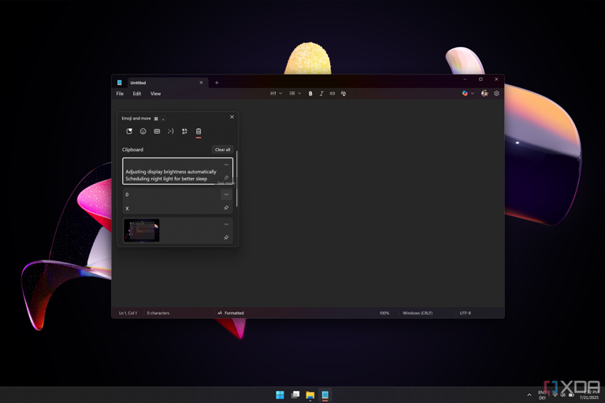

Screenshot of Notepad on Windows 11 with the clipboard history menu open

Finally, we have what is arguably one of the best features in Windows 11, period — in my opinion, anyway. The clipboard history is a feature that lets your computer save multiple items you've copied onto your clipboard, making it so that you can easily paste them later, even if you've copied something else in the meantime. I find it particularly useful when writing weekly reports when I may have to copy the title and URL of an article, since it lets me copy both things first and then paste them without having to swap back and forth between the two windows or tabs.

Clipboard history can be accessed by pressing **Windows + V** on your keyboard, but the first time you press this shortcut, it won't work yet. You'll need to click the **Turn on** button first, so if you're setting up a new PC, I recommend doing this as early as possible so you don't get a surprise later when you need it and realize it didn't actually save the items you just copied.

**Making the most out of Windows**

It's much more typical to hear someone complain about the unnecessary bloat Windows includes with its installation (I'm guilty of that behavior, too), but it's almost more surprising how many features that are useful Windows doesn't include or disables out of the box. I can't imagine using my PC without clipboard history, and night light has saved me so many headaches when work late at night. These things should either be enabled by default or made more obvious, yet they require you to look for them, which is a bit of a bummer.